How is the U.S. Constitution organized?

First...it has an introduction paragraph! (Just like your hamburger essay!!!)
The introduction to the U.S. Constitution is called the PREAMBLE.
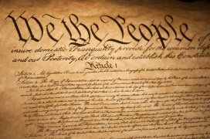
The U. S. Constitution

Preamble- Introduction paragraph of the
U.S. Constitution

Articles- Are the “body” or “burger patty” paragraphs of the U.S. Constitution. The Articles establish how our government will run.

- Article 1- Longest part of the Constitution
It creates the _________________________ Branch of our government, which we call Congress. This branch of government makes our government a ______________________________________________________, because we elect people (senators and representatives) to represent us in this branch.

Congress is divided into 2 parts:
The _____________________ and
The ___________________________________________________
Legislative branch is the LAW MAKING branch!
They make the laws.

- Article 2-Creates the ____________________________
Branch of our government. This is the branch that is managed by our country’s president. This branch is responsible for executing (like executive!) the laws. This means they carry out the laws that are passed.

- Article 3-Creates the ____________________________ Branch of our government. This branch is headed by the Supreme Court of the United States of America. They are the experts of our Constitution! They review laws and court decisions to make sure they are, “constitutional.”
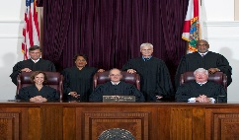
This branch interprets the laws.

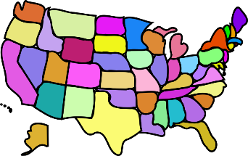
- Article 4-Outlines (puts in writing- expresses) the POWERS of the STATES. It details how states may interact.
We’ve got our own POWERS

- Article 5-Gives the ability and directions for how the Constitution can be changed. A change to the Constitution is called an AMENDMENT.

- Article 6-Establishes FEDERALISM- the division of POWER between the states and the Federal/National government. This Article also establishes the U.S. Constitution as the SUPREME LAW OF THE LAND. If a state law and federal law disagree-federal law wins.

- Article 7-Ratification. This established that 9 of the 13 states had to RATIFY or APPROVE the Constitution for it to become the Supreme Law of the Land. It was not ratified until 10 AMENDMENTS were made to it. These first 10 AMENDMENTS are called THE BILL OF RIGHTS.

The U.S. Constitution was RATIFIED (Approved) in March of 1789!!!

Amendments- changes made to the U.S. Constitution

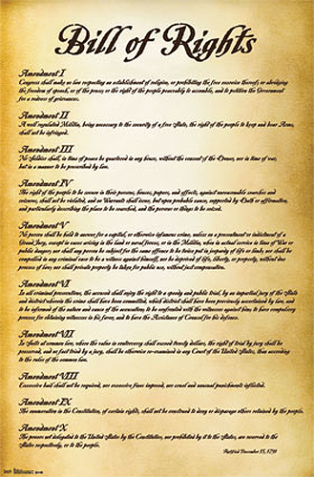
The first 10 Amendments are called the...

