Civics Unit 2 Vocabulary

Amend- To change or Modify
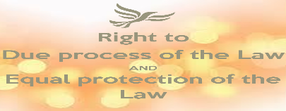
Due Process of Law- Protection against unfair government actions and laws

Confederation- A permanent union of the states
Denied Powers- Powers that Congress and States DO NOT HAVE, as written in the Constitution

Expressed Powers- Powers that are given in writing (expressed) in the Constitution

Implied Powers- Powers not in writing, but are used to carry out expressed powers (powers that are in writing).

Reserved Powers- Powers the Constitution doesn’t list for Congress or deny in writing to the states.
Ratify- is to approve formally
Provisions- are preparations/the state of being prepared

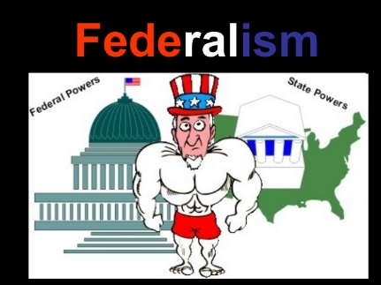
Federalism is the division of power between the Federal and State Governments

